Innovative Mechanization of Garlic in Vessalico (North Italy)

Peruzzi, A., Raffaelli, M.¹, Fontanelli, M. ¹, Frasconi C., ¹ Lulli L., ¹ & Ginanni, M.

Key words: garlic, physical weed control, organic farm, rolling harrow, flame weeding.

Abstract

Vessalico is a small village close to Imperia (Liguria region), where garlic is a typical crop. The garlic of Vessalico is a product that is very appreciated being one of the most traditional and top quality food in Italy. The division of Agricultural Machinery and Farm Mechanization of the Department of Agronomy and Agroecosystem Management and the CIRAA “E. Avanzi” of the University of Pisa, in collaboration with the Agriculture and Civil Defence department of the Liguria Region and the cooperative of farmers “A Resta”, carried out a trial aimed to study the possibility of introducing a mechanization chain in order to solve the main agronomic problems of the garlic cultivation in this area, such as sowing, weed control and harvesting, thus improving garlic yield and quality. Ordinary organic garlic crop management was compared with an innovative system in which physical weed control was carried out using a rolling harrow, two flame weeding machines and a precision hoe. The innovative treatments increased whole plant and bulbs dry weight of about 38 and 78% respectively, and reduced weed biomass at harvest up to 77%.

Introduction

Vessalico is a village (Latitude 44°3 N, Longitude 7°58’ E) in the district of Imperia, Region Liguria, NW Italy. The farms in this area are very small, and crops are grown in small terraced plots. As a result, operating machines must be handy and not cumbersome. Garlic is the main crop in this area, and it is sold as dried or processed high quality product, that is famous worldwide. Furthermore all the garlic cultivation of the area is organic, and it gives an added value to the crop. The division of Agriculture Engineering and Farm Mechanization Departement of Agronomy and Agro-Ecosystem Management and the CIRAA “E. Avanzi” of the University of Pisa, in collaboration with the Agriculture and Civil Defence department of Liguria and the Cooperative of farmers “A Resta”, carried out an experimental test, aimed to study the possibility of introducing a mechanization chain to solve the main agronomic problems of the garlic cultivation in this area, such as sowing, weed control and harvesting, thus improving garlic yield and quality (Peruzzi et al. 2007).

Materials and methods

The research was carried out in 2006-2007 in Vessalico (Imperia, Italy). The ordinary organic garlic cultivation was compared with an innovative system. The farmers of Vessalico usually plant the bulbs using a “one row” potato planter, modified for garlic. This equipment allows a reduction in working time compared to hand sowing, but it places the bulbs too deep in the soil, making the emergence of the plants difficult. The inter-row space is 50 cm. Weed control is carried out with a self propelled cultivator between the rows and by hand in-row. This technique is very expensive and can damage the garlic root system if the weeds are too much developed.

Concerning the innovative system, three different equipments for physical weed control were used: a rolling harrow, two flame weeding equipments and a precision hoe, all having a working width of 1.4 m. (figure 1).

The rolling harrow is equipped with specific tools. The tools are spike discs placed at the front and gage rolls mounted at the rear. The front and rear tools are connected by an overdrive with a ratio equal to 2. The disc and the rolls can be placed differently on the axles: in close arrangement, in order to create a very shallow tillage (3-4 cm) of the whole treated area (for seedbed preparation and non-selective weed control after false seed bed) and in spaced arrangement, in order to create efficient selective post emergence weed control (for precision inter-row weeding) (Peruzzi, 2005 and 2006).

The flamer is an open flame machine equipped with five 25 cm wide rod burners. In the experimental field trials the operative machine was used at crop emergence treatment with a driving speed of about 3 km h⁻¹ and different LPG pressures. During the trials a hand flamer, equipped with a one 15 cm wide rod burner and LPG pressure of 0.2 MPa, was also used.

The precision hoe is equipped with a seat and steering handles and directional wheels. The machine is equipped with six working units connected to the frame by means of articulated parallelograms. Each working unit is provided with a 9 cm wide horizontal blade and two couples of specific tools (elastic teeth suitable as vibrating tines and torsion weeder) in order to perform both inter and intra row weed control.

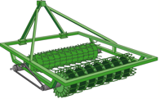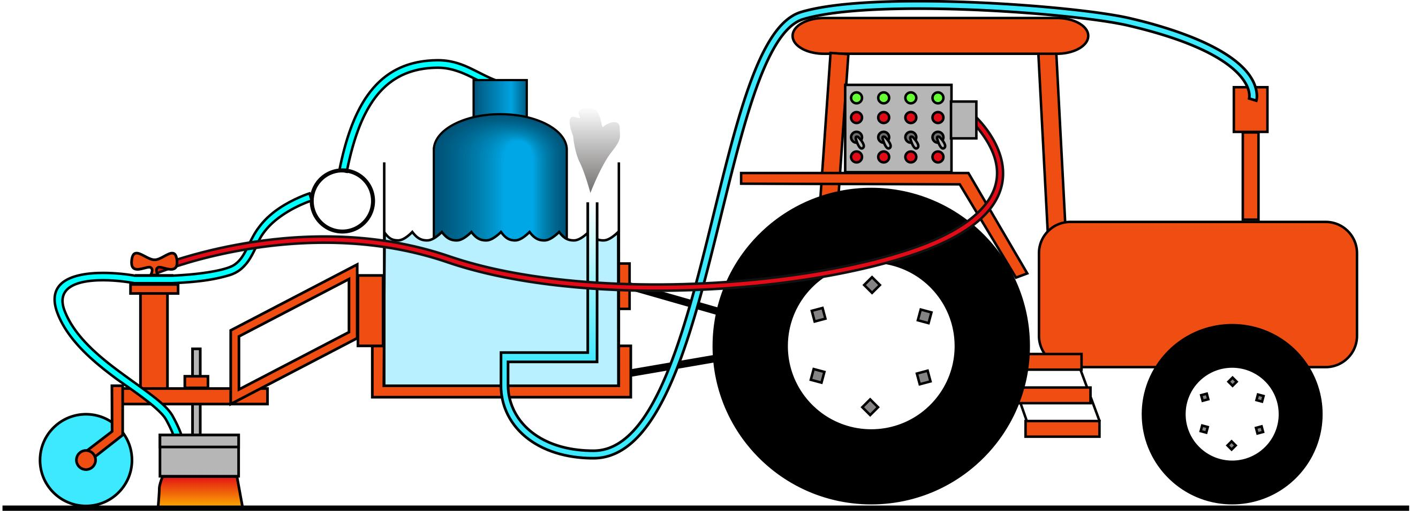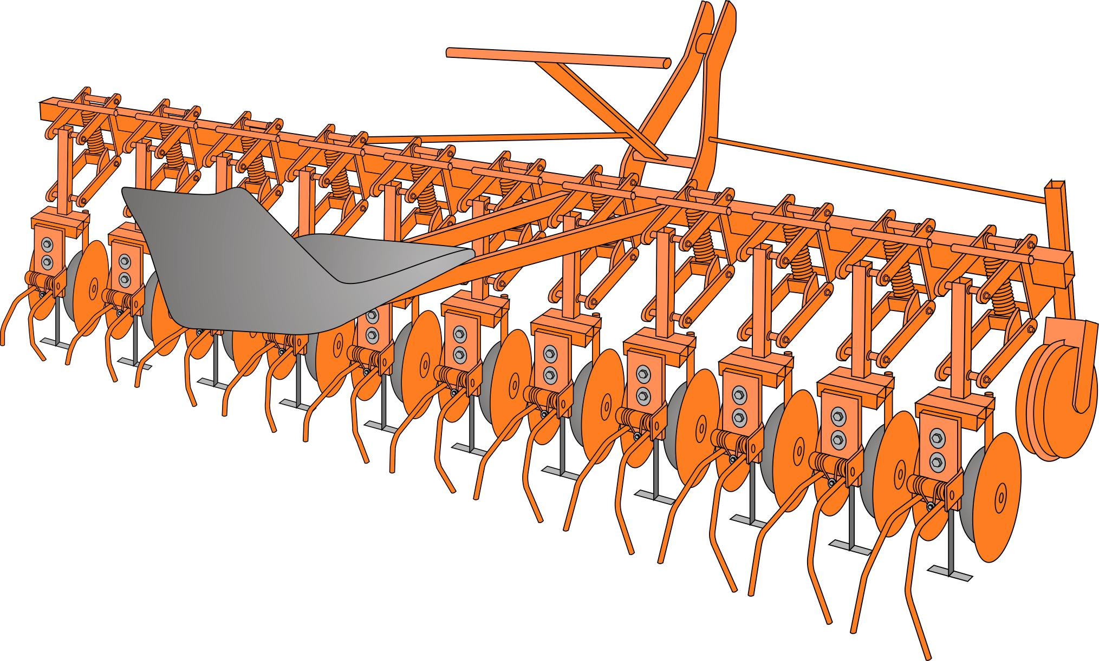
Figure 1: The equipments used for physical weed control: rolling harrow (left), flame weeding machine (middle), precision hoe (right).

The innovative weed control strategy consisted in a false seedbed technique performed with the rolling harrow, followed by flame weeding after crop emergence, as garlic can tolerate an exposure to thermal radiation for a few digits of second. Further interventions of weed control were performed by means of flame weeding or precision hoeing. Harvest was completely manual for both systems, because the garlic plants are dried with whole leaves, in order to twist them in the traditional strings (typical product manufacturing of the area).

During the experimental trials, physical weed control treatments were differentiated. Firstly, a false seed bed was performed with the rolling harrow on each experimental plot. Subsequently, garlic was manually sown in three rows spaced 20 cm apart. At early post emergence, an intervention of flame weeding was carried out at different working pressures (0.2; 0.3; 0.4; 0.5 MPa) using a 3 km h⁻¹driving speed. At the fourth leaf stage, three different secondary treatments for each working pressures were performed: precision hoeing with vibrating tines + torsion weeder, precision hoeing + torsion weeder and manual flame weeding (with a knapsack equipment and a working pressure of 0.2 Mpa). On some experimental plots, no secondary treatment was performed. Weed inter-row and intra-row density was determined on a basis of 25×30 cm² sampling area. At harvest crop production and weed biomass were determined. The experimental design was a strip plot with three replicates. Data collected were analysed by ANOVA. Treatment means were separated by Fisher's least square difference at P< 0.05 (Gomez e Gomez 1984).

Results

Data collected 29 day after the first flame weeding treatments showed that the most efficient working pressure in controlling inter-row weeds was 0.3 MPa. Weed density recorded 35 day after the secondary treatment revealed significant differences between the treated and untreated plots, but no significant differences were observed between the systems. The weed flora percentage reduction ranged from 24 to 57%.

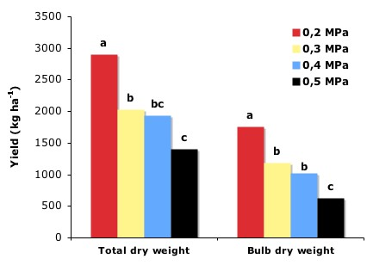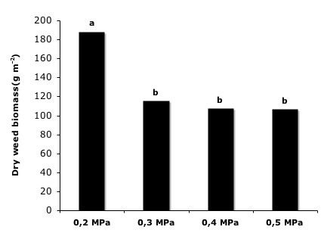
Figure 2: Effects of the different flame weeding working pressures on crop production (left) on weed biomass at harvest (right). Different letters indicate significant difference (LSD P<0.05).

Significantly higher total dry weight and bulb dry weight were observed when using a working pressure of 0.2 MPa. No significant differences were observed between the secondary treatments. As with weed dry biomass, significant differences between the different working pressures used in the first flame weeding intervention were noticed, with higher values for 0.2 MPa (Figure 2).

Comparing the data collected on innovative experimental plots treated with a working pressure of 0.2 MPa with the ones obtained on field managed in a traditional way, a significantly higher production in terms of total and bulbs dry weight, and a significant lower value of weed biomass at harvest were observed.

Discussion

Weed control is the main agronomic problem of garlic crops in this area. Flame weeding seems to ensure good weed control. The working pressure of 0.3 MPa ensured the best weed control results both in terms of density and biomass at harvest. The working pressure of 0.2 MPa allowed to obtain the highest yield and to control the weed flora in a acceptable way, in comparison with the traditional weed management. In order to explain these results, it should be considered that, during flame weeding intervention (with constant driving speed), the higher LPG pressure resulted in higher transmitted energy.

Conclusions

The introduction of a mechanization chain in organic garlic in Vessalico seems to be feasible, using suitable operative machines available on the market, with opportune setting up and possible modifications. Regarding weed control, the experimental trials carried out by means of the equipments realized at the University of Pisa showed interesting results, that aim to identify a more precise definition of effective weed management and its practical applications.

Acknowledgments

The authors would like to thank Mrs Roberta Del Sarto, Mr Alessandro Pannocchia, Mr Paolo Gronchi, and Mr Calogero Plaia of the M.A.M.A.-D.A.G.A. and C.I.R.A.A. of the University of Pisa, and also all the members of the “A Resta” farmer cooperative for their precious collaboration and participation in the experimental work.

References

Gomez K.A., Gomez A.A. (1984) Statistical procedures for agricultural research II edition. Eds John Wiley & Sons U.S.A.

Peruzzi A. (2005): La gestione fisica delle infestanti su carota biologica e su altre colture tipiche dell’altopiano del Fucino . Stamperia Editoriale Pisana Agnano Pisano (PI).

Peruzzi A. (2006): Il controllo fisico delle infestanti su spinacio in coltivazione biologica ed integrata nella Bassa Valle del Serchio. Stamperia Editoriale Pisana Agnano Pisano (PI).

Peruzzi A., Raffaelli M., Ginanni M., Fontanelli M., Lulli L., Frasconi C. (2007): La Meccanizzazione dell’Aglio di Vessalico. Proceedings Convegno Nazionale III V e VI Sezione AIIA Pisa-Volterra 5-7 settembre 2007 “Tecnologie innovative nelle filiere: orticola, vitivinicola e olivicolo-olearia.” p. 120-123.

Division of Agricultural Engineering and Farm Mechanization - Department of Agronomy and Agro-ecosystem Management - University of Pisa, Via del Borghetto 80 - 56124 Pisa PI, Italy, E-Mail aperuzzi@agr.unipi.it, Internet www.agr.unipi.it.
CIRAA “E. Avanzi”, University of Pisa, Via Vecchia di Marina 6, 56010 S. Piero a Grado PI; Italy, E-mail ginanni@tiscali.it

