EUROPEAN ORGANIZATION FOR NUCLEAR RESEARCH
ORGANISATION EUROPEENNE POUR LA RECHERCHE NUCLEAIRE

CERN - PS DIVISION

PS/RF/Note 2000-011 (MD)

Evaluation of vector signal analyzer for
beam transfer function measurements in PS Booster

A. Blas, S. Hancock, S. Koscielniak, M. Lindroos, M. Sjostrom

Abstract

The purpose of the 18th p.m. and 25th a.m. November 1999 MDs was to evaluate an "off the shelf" commercial vector signal analyzer as a replacement for the aging hardware that is presently being used to perform beam transfer function (BTF) measurements in the CERN PS Booster. The results are very positive for the longitudinal coasting beam BTF, and moreover the same equipment can be used for the Schottky scan. No evaluation was made for the transverse BTF.

GENEVA

14 June 2000

Beam Transfer Function Measurement

Introduction
It has been suggested to replace the aging rack of equipment that is the present PS Booster BTFM hardware by an “off the shelf” vector signal analyzer (VSA). The purpose of several MDs, particularly the 18th and 25th November ones, was to be certain that a VSA offers all the necessary functionality to make BTF and Schottky measurements. For this purpose of evaluation, an HP 89410A vector signal analyzer was graciously loaned by Roland Garoby. In the text below we shall give a recipe for set up and make some comments about experience with BTF measurements. The details of the hardware setup evolved between the 18th and 25th November.

Cavity transfer function
In order to establish that we understand the VSA measurement/setup, one may make a simple test such as measurement of the cavity transfer function. The source is split: one half goes to the special excitation input of the cavity (SWA-IN), the other half goes to channel #1 of the VSA. The C04 gap return signal is connected to channel #2. Load file “cavity18nov.sta” to put the instrument in a suitable status for automatic measurement of the transfer function using a chirp excitation. One finds the results very reproducible pulse by pulse, with the "familiar" circle response in the polar diagram. In order not to have the power amplifier disabled in such a test, it is important to make sure that the excitation level is below the limits set on the power equipment (<-5 dBm).

Choice of harmonic for BTFM
There is a band of beam frequencies about each revolution harmonic number “n”. There is the same signal energy in all bands. However, the width of each band scales as “n” while the power spectrum scales as “1/n”. Hence the choice of harmonic is always a compromise between frequency resolution and signal intensity (i.e. signal to noise). The higher bands overlap making them un-usable. We used 6th harmonic for the carrier because Michel Chanel earlier chose this as a good compromise for his Schottky scan.

Cable connections for BTFM
In basic terms, the cable connections are:
C04 gap signal (NOT logarithmic detect) connected on channel #1.
Beam current pick-up from one of the four rings connected on channel #2 of VSA.
External trigger connected from rack #710.
Gated DC signal (-2.4V) connected to the tuning offset input of the power equipment.
However, details were refined between the 18th and 25th.

18th Nov
Both source and gap return must be PPM gated.
Gating of the source protects beams other than the one under investigation.
Gating of the C04 gap return protects the VSA from other users of C04.
Gating is done by "TRIPLE SP2T" in rack # 710 composed of SWA,B and C.
Source is connected to SWA-IN, and gap return to SWB-OUT.

25th Nov
In addition to the source and gap gating, the beam signal was gated to protect the VSA instrument from other cycles. Hence, one has the following cabling in rack #710.
Gating of beam and gap return by "TRIPLE SP2T": beam current signal connected to SWA-IN and appears from SWA-OUT to drive the VSA channel #2; gap return connected to SWB-IN and appears from SWB-OUT to drive the VSA channel #1.
Gating of source done by “RF SWITCH SP2T": “noise” source is connected to SWA*-IN and appears from SWA*-OUT to drive the cavity.

Cavity voltage properties for BTFM
Set "RF-ACT" of C02 and C016 equal "OFF".
Set "RF-ACT" of C04 "ON", BUT set the cavity voltage to zero; e.g. GFA setting -4volts.

C04 cavity tuning for BTFM
The C04 cavity bandwidth must overlap the band of excitation frequencies. Ideally, for stability reasons, the cavity should be detuned with resonance frequency slightly below the beam frequencies so that it presents a capacitive impedance to the beam spectrum (Robinson criterion). If there is a problem with tuning, then put the VSA on a span of about 6-10 MHz and look for the cavity resonance using the VSA in power spectrum and video averaging mode. The resonance is about 1 MHz wide, and so you need a wide span to see it. However, if the cavity is driven wideband for too long, temperature protection circuitry will disable all the power stages of the RF equipment.
In order not to disturb other users, the C04 cavity tuning must be PPM modulated; this was accomplished in different ways during the 18th and 25th MDs.

18th Nov
Launch the BTFM program. Choose Control, ring #k & longitudinal. Load the settings file R2long181199shane.set. The program will arrange the cavity detuning assuming a 6th harmonic carrier frequency; if a different value is required then adjust the value in the *.set file. An inverter had to be included so as to obtain the expected –2.4 V.

25th Nov
Later, the BTFM program was bypassed, and a PPM triggered d.c. voltage source was used to drive the C04 cavity detuning. An offset of about –2.4volt gives 6th harmonic.

VSA settings
It is not completely sure how much of the instrument status is actually recorded, so we shall mention a few optimizations.
Using the system-utility reconfigure the memory to max out the number of frequency and time points. Under SOURCE, find the chirp excitation which appears superior to the noise excitation (to be checked!), and "single" preferable to "repeat". Under TIME, make sure the main window and gated times are "maxed" out. Under WINDOW, select uniform and max out the number of frequency points. The “average” feature is only useful if there are large shot-to-shot variations in the measured spectra. Under AVERAGE select "time" which will give an arithmetic average. Do NOT select "video", as this uses an r.m.s. averaging which will destroy the phase information and prevent you from making polar plots. [The "video" averaging is appropriate to Schottky scans.] The averaging will continuously update all screen traces that are defined (up to four).

VSA tips
HELP?! Yes, there is an INDEX! Select HELP “hardkey” and then #1 on the numeric key pad. Then scroll through the index and select the desired item with #4 on the key pad.
After a status file (*.sta) is loaded, other measurement data can easily be assigned to the traces using "MEASURE DATA" and the kind of trace (spectrum, polar, etc) selected with "DATA FORMAT".
To place measurements into the data registers D1,D2, etc. use the SAVE/RECALL and save a trace to a data register.
When using the math functions, avoid complicated expressions involving sums and products of real and imaginary parts of spectra as this may quickly lead to memory exhaustion of the VSA.

Comments about the BTF phase advance
There is a phase advance of the wave-group between cavity/excitation and beam pick-up; for a given angular frequency ω the total phase is denoted by φ at the fundamental and θ=m×φ at the m^{th} harmonic.
$$\text{BTF}=\frac{I(ω)}{V(ω)}e^{iθ}≈\frac{ω}{m}\left\{π+\text{iHT}\right\}\frac{\text{df}}{\text{dp}}$$
where m is the harmonic # of the carrier and "HT" is the Hankel Transform operator (which is pure real) and f(p) is the momentum/frequency distribution. If theta=0, then
$$ℜ\left[\frac{I(ω)}{V(ω)}\right]≈\frac{ω}{m}π\frac{\text{df}}{\text{dp}}|_{p=ω}$$
Evidently getting theta "wrong" will mix the real and imaginary parts. Marten's software would be valuable for this kind of analysis if the BTFm if reborn in the form of a vector analyzer "box".

18th November MD results
Initially, Fredi and Mauro spent some time diagnosing and fixing up the C04 cavity which refused to tune. Later 3 turns were injected (2.6E12ppp) and the instrument status loaded into the VSA using the file “btf18nov.sta”. This file will set the frequency span to 60 kHz centred on the beam harmonic frequency of 3.95MHz and set the four traces A,B,C,D to be polar plot, real and imaginary parts of F3 and the power spectrum of F3. Examples of these traces are given in Figure 1 and Figure 2. The math-function F3= K1*SPEC2/SPEC1 is defined manually.
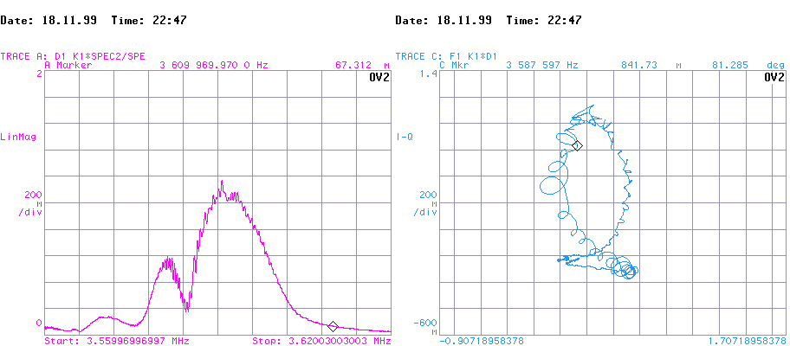
Figure 1: C16-OFF, linear magnitude and polar plots of the BTF from files “ampli18nov.dat” and “polar18nov.dat ”.
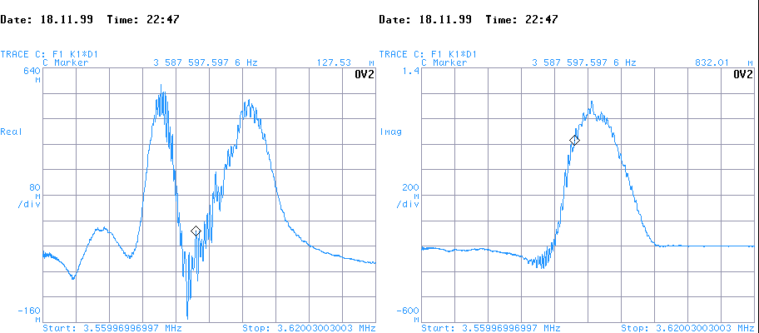
Figure 2: C16-OFF, in-phase and quadrature parts of BTF from files “real18nov.dat” and “imag18nov.dat ”.
Though averaging helps somewhat, the pulse to pulse variation of the BTFs makes tuning and interpretation quite difficult. Further, at both extrema of the frequency span, the ratio I/V became small but very noisy and is responsible for a lot of unnecessary spikes and fuzz in the polar plot (and lots of confusion!). Most probably data at the ends of the range should be truncated -- this would need offline software.

Choosing theta
For a single-humped momentum distribution f(p), the real part of the BTF is zero at the frequency for which df/dp=0, that is for the frequency at the maximum of the distribution f(p). At this same frequency, the modulus of the imaginary part of the BTF is the maximum possible within the spectrum. These statements are true irrespective of whether or not the distribution f(p) is symmetrical about its maximum. Hence if θ is properly adjusted, the maximal imaginary part of the BTF occurs when the real part is zero as can be seen in the polar plot. Note, however, after this adjustment is accomplished the locus BTF(ω) in the complex plane is not necessarily symmetrical about the imaginary axis unless f(p) is symmetric about its maximum. Note also that due to unbalance in the cables delay there is an added phase error when moving away from the set point (10º with 30 kHz and 1μs difference).

The constant K1 accounts for the phase advance of the wave-group between cavity and beam pick-up. Math functions and constants are not saved in the status file, and so K1 must be reset. During the MD, theta was adjusted as follows. Display two windows: the power spectrum of the BTF and the phase advance of the BTF (preferably non-wrapped). Read off the phase phi at the maximum of the power spectrum directly from the scope (using the cursor). Then set K1=cosθ-I×sinθ. Ideally one should look at the r.m.s. (video) average of the power spectrum and the arithmetic (time) average of the phase advance trace; but the scope does not allow this and so one may have to seek a compromise involving two sets of measurements. For 6th harmonic θ appears to be between 60 and 90 degrees, but it is hard to say exactly where; and it changes if a different harmonic is utilized.

25th November MD results
Fredi and Mauro spent the morning fixing problems with the C04 system, and were later joined by Mats, Shane and Marten Sjostrom. The MEFLAT cycle with 3 turns injected (2.4E12ppp) was utilized. BTF measurements were made with C16 On and C16 OFF, that is with and without empty bucket deposition. The vector signal analyzer settings are stored in “25nov.sta”.

Choosing theta
Introducing high harmonic empty buckets into the coasting beam produces a double peaked momentum distribution. In principle, one could first adjust θ with C16-OFF and then use the same setting for the case C16-ON. However, we chose instead, to test the following hypothesis. The derivative of the momentum distribution is zero where there are no particles, and so for the corresponding frequencies the real part of the BTF should be zero. The imaginary part is given by a convolution-like integral and can be anticipated to be small but non-zero at the frequency extrema of the BTF.
Consequently, for C16-ON, we read off the phase directly from the VSA plot (at the two ends of the frequency span) and adjusted K1 (in amplitude-angle form) to give the 90º phase shifts anticipated. The same K1 setting was later used for the case C16-OFF and continued to give the 90º phase shifts anticipated towards the ends of the frequency span.

C16-ON
Using harmonic number h=20 for the empty bucket deposition, the C16 program is shown in figure 3 and consists of three “clearing sweeps” followed by an empty bucket deposition. The radial position offset GFA scans over ±4.5V giving a frequency offset of ±3.16 kHz @ h=1, or 63.2 kHz @ h=20. The C16 cavity voltage is most probably 3 kV. The VSA external triggering was set to 1 ms after the C16 cavity voltage goes to zero, that is 15 ms after injection or C-train 290 ms. The corresponding BTF plots are given in Figure 4 and Figure 5.
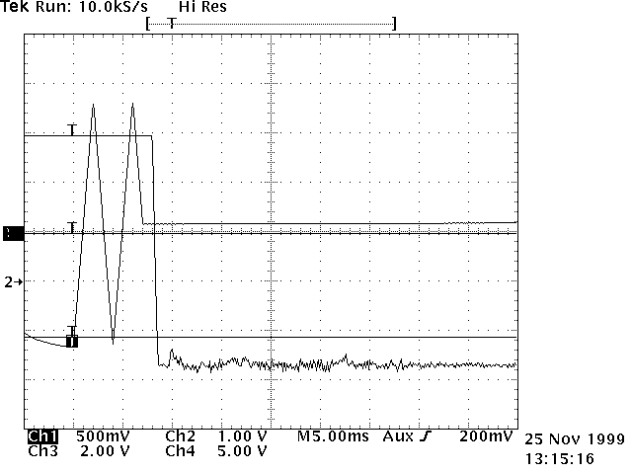
Figure 3: C16 cavity frequency (channel #3) program and voltage law .

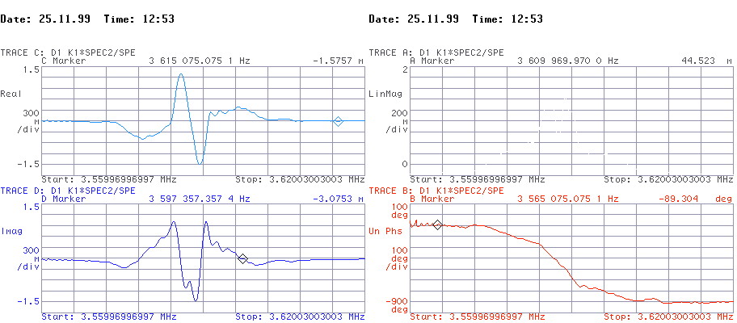
Figure 4: C16 ON, in-phase, quadrature; amplitude and phase plots from file “tr25nova.dat ”.
Unlike the "old BTFM" and the BTF MD of 18th November, the data from a single shot has sufficiently small noise to be easily interpretable without averaging. As witness of this, the in-phase, quadrature, amplitude and phase, and polar plots of the BTF made at 13:07 pm from file “shane1.dat”, also with C16-ON, are virtually identical with figures 4 and 5.

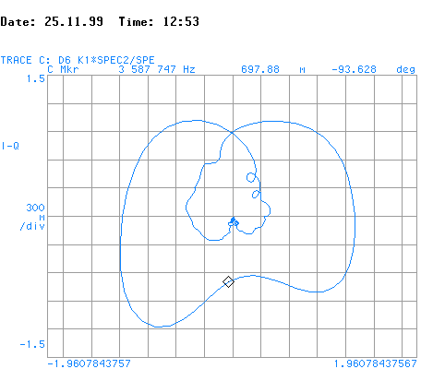
Figure 5: C16 ON, polar plot of BTF from file “tr25nova.dat”.

C16 OFF
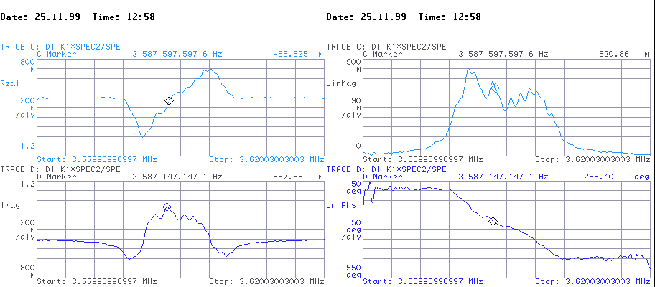
Figure 6: C16-OFF, in-phase, quadrature; amplitude and phase plots from file “tr25novb.dat ”.
Again, the data is sufficiently noise-free that single shots are easy to interpret and the repeatability is high. As witness, the in-phase, quadrature; amplitude and phase, and polar plots of the BTF made at 13:10 pm from file “shane2.dat”, also with C16-OFF, are virtually identical with Figure 6 and Figure 7.

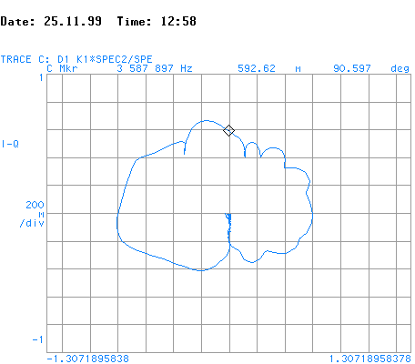
Figure 7: C16-OFF, polar pot of BTF from file “tr25novb.dat ”.

BTF versus Schottky scan
The principle advantages of the Schottky scan are that it is easy to set up (see below), that it is non-intrusive upon the beam distribution, and that it gives a direct measure of the particle density distribution. By contrast, one has to perform complex-number arithmetic and an integration to recover the momentum distribution from the BTF. However, the Schottky scan suffers from many disadvantages. (I) the phase information is lost, and so the spectra cannot be used to find the BTF nor a stability diagram (essentially the reciprocal of BTF). (II) it is inherently noisy, and so averaging is required, and so it is a lengthy measurement; by contrast the BTF can give a reasonable result in a single shot. (III) any coherent perturbation will generate signals that completely swamp the shot noise. Consequently, the Schottky scan is not the ideal tool to diagnose the effect of “cleaning sweeps” or of bucket depositions; indeed the scans can be so hard to interpret as to be meaningless. One source of coherent signals are “linacbubbles”; it seems that in most (but not all) cases these are not large enough to severely impact the Schottky scan.

Initial beam modulations?
There are grosser modulations than “linac bubbles” if a non-integer number of turns is used. After a systematic investigation (using the “Tomoscope”) of the debunching of various beams on an MEFLAT cycle with all cavities OFF, we conclude the beams are most uniform when exact integer filling is used. The suggestion that "1.1 turns is better than 1.0" turns out to be folklore. One example from this study is shown immediately below, namely the case of 0.9 turns. The reference RF has been carefully adjusted so that the hole debunches symmetrically. One may think either of the occupied or the un-occupied phase space as shearing, since the effect is the same. The “fan” of radial spokes composed of tiny circles is an artefact of the graphical interface which uses circles as a graphical primitive.
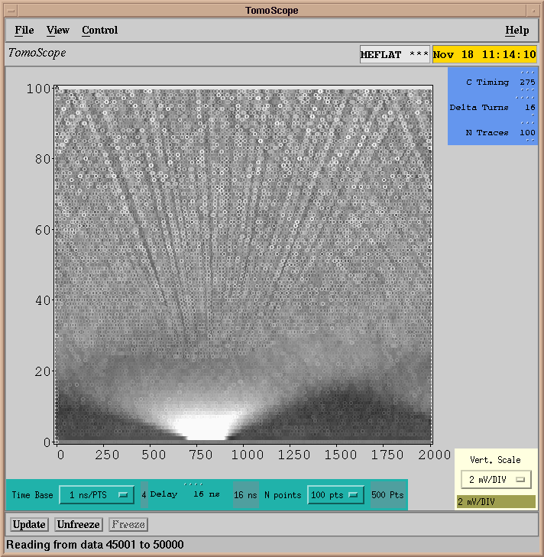
Figure 8: C16 Off, 0.9 turns injected, start @ 27s ms, span 2.67 ms .

BTF contamination
Not only is the BTFM intrusive upon the beam, it has a fundamental limitation: the BTF carrier frequency will upmix/downmix nearby Sckottky bands below/above into the band of frequencies we wish to measure. However, the shot noise is probably not large enough to be responsible for the substantial pulse to pulse variations in the BTF -- and that we should look for other explanations.

Pulse to pule variability
The pulse to pulse variation in the BTF is a true feature of the beam. In previous MDs, we have certainly seen the linac central momentum and r.m.s. momentum spread follow a stochastic pattern super-imposed on a limit cycle; and no-doubt other moments show similar behaviours. There are of course, many subtle impedance effects which can maintain and amplify features and structures surviving from the linac beam to the time of injection and beyond. One must not forget that (due to Landau damping) longitudinal instabilities display thresholding, so that no effects are seen at very low beam currents, and then they appear linearly with intensity above threshold. For instance, can C04 have spurious impedance effects on the beam? It is inevitable that further off-line processing of the spectra will be required that is well beyond the limited mathematical operations that the VSA can perform.

Baseline offset
The integral with respect to momentum of the real part of the BTF should be identically zero, even if one includes the shot noise. The fact that this integral is, in practice, rarely non-zero can be traced back to sampling errors (e.g. small number of frequency points, discretization errors in ADCs, etc.)

Schottky Spectra
The Schottky scan is simple to set up and simple to interpret provided coherent signals are small. Andreas, Mats and later Michel Chanel have already worked quite hard to get status settings for the VSA, and the files “state1511.sta”, “state1611.sta” and “state1611b.sta” (in chronological order) record a progression of refinement in the VSA setup for Schottky scans.
Some example scans from 16th November MD are given below (Figure 9) with and without the C16 bucket deposit. The C16 cavity program is simpler than given in Figure 3. GSVRFC16 (C16 voltage GFA) =3.0 volts for 4 ms, and 5.5 volt thereafter. GSRPOS (radial position GFA) sweeps from –3.5 V at injection to +4.0 volt in 2 ms, and then sweeps down to zero in 1 ms; and is constant thereafter.
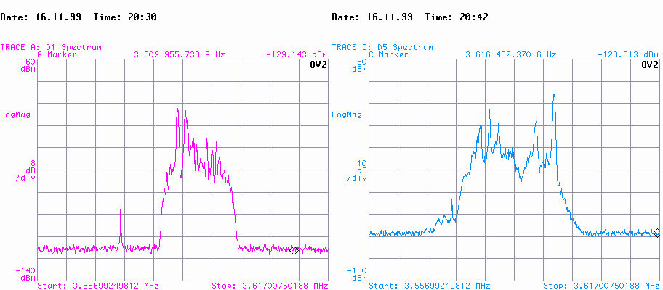
Figure 9: Schottky scan, 3 turns injected; left => C16 OFF; right => C16 ON .
The effect of the clearing sweeps and bucket deposition is to broaden the frequency spectrum substantially and to introduce a notch at around 3.60 MHz. The large spikes appearing in the data are more likely coherent signals than true local peaks of very high particle density.
ΔT(kev)=192.8(eV/Hz)×Δf(kHz) @ h=1. With C16 Off, the full width frequency spread is ≈15 kHz @ h=6, leading to an energy full width of 480 keV. With C16 On, the frequency spread is ≈24 kHz, leading to an energy with of 770 keV.

This is particularly important when noise is used; whereas the chirp is a short burst, the noise excitation is continuous.

